##### LOW COST APPLICATION MOTION HAND GESTURE CONTROLLER USING ADAPTABLE SENSORS

##### A PROJECT REPORT

###### ***Submitted by***

##### GADIKOTA BRAMHA THEJA [REGISTER NO:211417104064]

**BUSH ASHWIN R M [REGISTER NO:211417104088]**

***in partial fulfillment for the award of the degree***

***of***

##### BACHELORE OF ENGINEERING

IN

**COMPUTER SCIENCE AND ENGINEERING**

**PANIMALAR ENGINEERING COLLEGE, CHENNAI-600123.**

ANNA UNIVERSITY : CHENNAI 600 025

**APRIL 2021**



##### LOW COST APPLICATION MOTION HAND GESTURE CONTROLLER USING ADAPTABLE SENSORS

##### A PROJECT REPORT

###### ***Submitted by***

##### GADIKOTA BRAMHA THEJA [REGISTER NO:211417104064]

**BUSH ASHWIN R M [REGISTER NO:211417104088]**

***in partial fulfillment for the award of the degree***

***of***

**BACHELOR OF ENGINEERING**

IN

# COMPUTER SCIENCE AND ENGINEERING

PANIMALAR ENGINEERING COLLEGE, CHENNAI-600123.

ANNA UNIVERSITY: CHENNAI 600 025

##### APRIL 2021

**BONAFIDE CERTIFICATE**

Certified that this project report **“LOW COST APPLICATION MOTION HAND GESTUR CONTROLLER USING ADAPTABLE SENSORS”**

is the bonafide work of “**GADIKOTA BRAMHA THEJA (REGISTER NO:211417104064) , BUSH ASHWIN R M (REGISTER NO:211417104088)”** who carried out the project work under my supervision.

**SIGNATURE SIGNATURE**

**Dr.S.MURUGAVALLI,M.E.,Ph.D., Mr.C.Thygarajan**

**HEAD OF THE DEPARTMENT ASSOCIATE PROFESSOR**

DEPARTMENT OF CSE, DEPARTMENT OF CSE,

PANIMALAR ENGINEERING COLLEGE, PANIMALAR ENGINEERING COLLEGE,

NASARATHPETTAI, NASARATHPETTAI,

POONAMALLEE, POONAMALLEE,

CHENNAI-600 123. CHENNAI-600 123.

Certified that the above candidate(s) was/ were examined in the Anna University Project Viva-Voce Examination held on...........................

**INTERNAL EXAMINER EXTERNAL EXAMINER**

**ACKNOWLEDGEMENT**

We express our deep gratitude to our respected Secretary and Correspondent **Dr.P.CHINNADURAI, M.A., Ph.D.** for his kind words and enthusiastic motivation, which inspired us a lot in completing this project.

We would like to extend our heartfelt and sincere thanks to our Directors **Tmt.C.VIJAYARAJESWARI**, **Thiru.C.SAKTHIKUMAR,M.E.,** and **Tmt. SARANYASREE SAKTHIKUMAR B.E.,M.B.A.,** for providing us with the necessary facilities for completion of this project.

We also express our gratitude to our Principal **Dr.K.Mani, M.E., Ph.D.** for his timely concern and encouragement provided to us throughout the course.

We thank the HOD of CSE Department, **Dr. S.MURUGAVALLI , M.E.,Ph.D.,** for the support extended throughout the project.

We would like to thank my **Project Guide** ……………………… and all the faculty members of the Department of CSE for their advice and suggestions for the successful completion of the project.

##### GADIKOTA BRAMHA THEJA

**BUSH ASHWIN R M**

**ABSTRACT**

Today we are surrounded by innovative technology and it is evolving day by day. Among these technologies, the hand gesture is one of such techniques that helps humans to interact with the computer and control its functions using some pre-defined gestures. Usage of hand gesture technology eliminates the use of hardware we use traditionally such as mouse and keyboard as our interaction with the computer is going to be contactless making it a more affordable approach. This technology uses ultrasonic sensors that work on the principle of ultrasonic waves produced by the gesture making the interaction process faster. This technology is thus time-saving, cost-effective, and efficient. The hardware requirement of this technology consists of Arduino UNO board, low in cost sensors, and a personal computer making it highly affordable. This technology not only brings advancement human-computer interaction but also speeds up the process, making it a productive approach to choose.

**Keywords:** Arduino, Gesture, Laptop, PyAutoGUI, Python, Ultrasoni

# CONTENTS

|  |  |  |
| --- | --- | --- |
| **CHAPTER.NO** | **NAME** | **PAGE NO** |
| 1 | INTRODUCTION | 1 |
| 2 | MOTIVATION | 2 |
| 3 | LIETRATURE SURVEY | 3 |
| 4 | HARDWARE COMPONENTS | 4 |
| 5 | SOFTWARE APPLICATIONS | 7 |
| 6 | BENFITS OF THE PROJECTED SYSTEM | 8 |
| 7 | ARCHITECTURE | 9 |
| 8 | CIRCUIT DIAGRAM | 10 |
| 9 | PYTHON CODE | 13 |
| 10 | AURDUINO CODE | 15 |
| 11 | IMPLEMENTATION | 21 |
| 12 | OUTPUT | 32 |
| 12. | FUTURE DEVELOPMENT | 33 |
| 13. | CONCLSION | 34 |
| 14. | REFERENCES AND BIBILIOGRAPHY | 35 |

**LIST OF FIGURES**

|  |  |
| --- | --- |
| Name | Page no |
| 1 Arduino UNO | 4 |
| 2 Ultrasonic sensors | 6 |
| 3 Jumper wires | 6 |
| 4 Basic layout | 9 |
| 5 circuit diagram | 10 |
| 6 Installation of python and Arduino | 21 |
| 7 python and Arduino code | 24 |
| 8 Volume up | 26 |
| 9 Volume down | 27 |
| 10 Forward | 28 |
| 11 Backward | 29 |
| 12 Play | 30 |
| 13 Pause | 31 |
| 14 Output | 32 |

**CHAPTER-1**

**INTRODUCTION**

Now a days Gesture controlled computers and laptop are getting very famous. This technique is called Leap motion which enables us to control certain functions on our computer/Laptop by simply waving our hand in front of it. It is very cool and fun to do it, but these systems are really priced very high. So in this project let us try building our own gesture control laptop/computers by combining the Power of Arduino and Python.

We will use two Ultrasonic sensors to determine the position of our hand and control a media player (VLC) based on the position. I have used this for demonstration, but once you have understood the project, you can do anything by just changing few lines of code and control your favorite application in your favorite way.

The concept behind the project is very simple. We will place two Ultrasonic (US) sensors on top of our monitor and will read the distance between the monitor and our hand using Arduino, based on this value of distance we will perform certain actions. To perform actions on our computer we use Python library. The commands from Arduino are sent to the computer through serial port (USB)

**CHAPTER-2**

# MOTIVATION

Automation of the existing technology is my motive in this project. This project is not only advanced but also cost effective when compare to the traditional approach. With very low cost IOT devices we can achieve this technique. If we will buy a laptop with leap motion technology or gesture deduction technology it will cost us a huge amount of money as these devices are very costly. So with this approach we can make our own gesture control laptop or system in very low cost

**CHAPTER-3**

# LITERATURE SURVEY

1. In this paper the author had told about how gesture has become an important means of communication in the physical world interaction with machines become very important and how we can control some of our application with gesture with the help of IOT devices such as Arduino UNO and ultrasonic sensors
2. This paper states that problem cause by keyboard and mouse sometimes can be helpful with this gesture based application as it is very easy to use. It uses very simple gesture to control the video to the people don’t have to learn machine like skills only the people have to remember the type of gesture to control the application
3. In this paper the author proposed that lots of technique are there to interact with humans and machine and one of them is hand gesture technique in this technique hand gesture is used to control the machine instead on mouse and keyboard. It is an effective and faster technique. To determine the user hand an ultrasonic sensor is used. By using this technique there is no need of physical connection between the humans and the machine.
4. In this paper the author states that gesture is an expression of emotion and physical behavior. Gesture can be used as a tool that can be used to interact and communication between the machine and the computer. Hand gesture is different from traditional hardware based method gesture that has been proposed has different types of concept like SVM, neural network, HMM, Arduino coding etc.

**CHAPTER-4**

**HARDWARE COMPONENTS**

1. **Arduino** - Arduino is an open-source electronics platform based on easy-to-use hardware and software. Arduino boards are able to read inputs

* light on a sensor, a finger on a button, or a Twitter message - and turn it into an output - activating a motor, turning on an LED, publishing something online. You can tell your board what to do by sending a set of instructions to the microcontroller on the board. To do so you use the Arduino programming language (based on Wiring), and the Arduino Software (IDE), based on Processing.

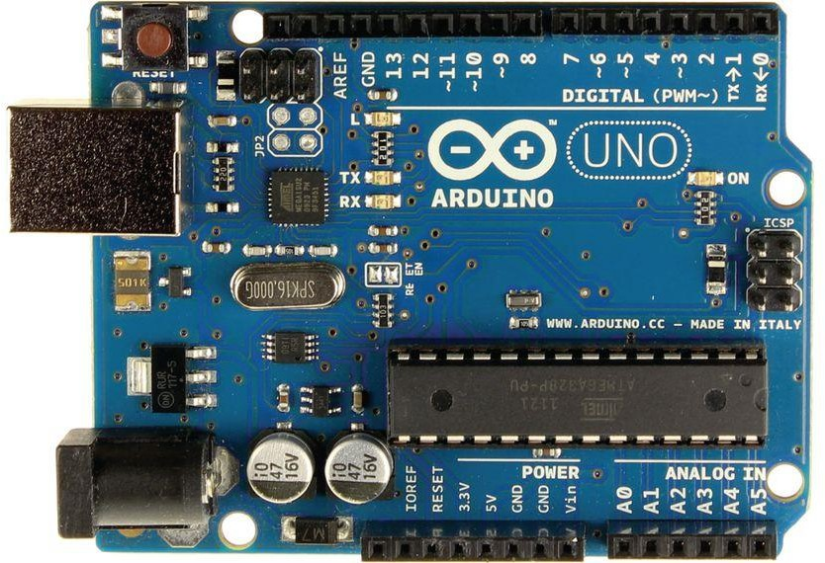

Fig 1: Arduino UN

1. **Two Ultrasonic Sensors (HC-SR04)** - HC-SR04 Ultrasonic Distance Sensor is a sensor used for detecting the distance to an object using sonar. It's ideal for any robotics projects you have which require you to avoid objects, by detecting how close they are you can steer away from them! The HC-SR04 uses non-contact ultrasound sonar to measure the distance to an object, and consists of two ultrasonic transmitters (basically speakers), a receiver, and a control circuit. The transmitters emit a high frequency ultrasonic sound, which bounce off any nearby solid objects, and the reciever listens for any return echo. That echo is then processed by the control circuit to calculate the time difference between the signal being transmitted and received. This time can subsequently be used, along with some clever math, to calculate the distance between the sensor and the reflecting object!

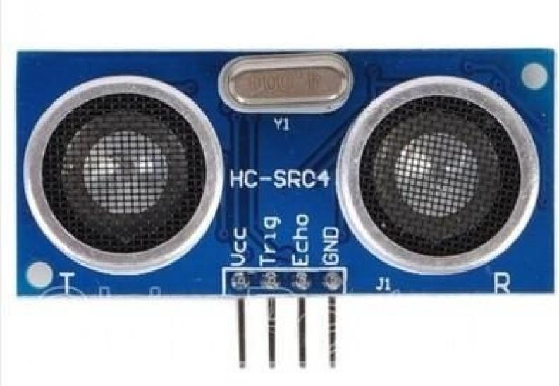

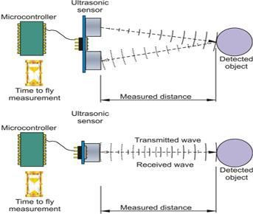 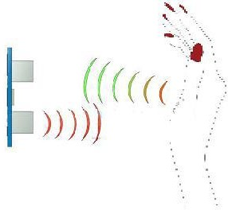

Fig 2: ultrasonic sensors

1. **jumper wires (male to male)** - A jump wire (also known as a Dupont Wire, jumper wire, or simply a jumper) is an electrical wire, or group of them in a cable, with a connector or pin at each end (or sometimes without them – simply "tinned"), which is normally used to interconnect the components of a breadboard or other prototype or test circuit, internally or with other equipment or components

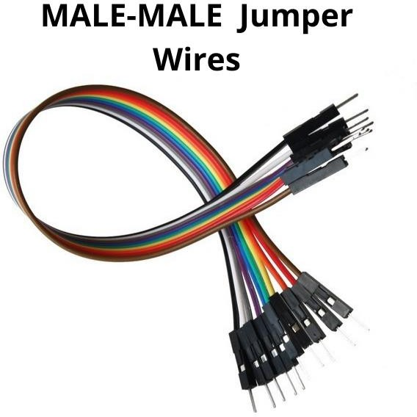

Fig 3: jumper wires

**CHAPTER-4**

**SOFTWARE APPLICATION**

1. **Arduino IDE -** The Arduino Integrated Development Environment (IDE) is a cross-platform application (for Windows, macOS, Linux) that is written in functions from C and C++. It is used to write and upload programs to Arduino compatible boards
2. **Python IDLE** - An IDE (or Integrated Development Environment) is a program dedicated to software development. As the name implies, IDEs integrate several tools specifically designed for software development. These tools usually include: An editor designed to handle code (with, for example, syntax highlighting and auto-completion)
3. **PySerial library** - (We will use to communicate with serial ports) PySerial is a library which provides support for serial connections ("RS- 232") over a variety of different devices: old-style serial ports, Bluetooth dongles, infra-red ports, and so on. It also supports remote serial ports via RFC 2217.
4. **PyAutogui library** - (We will use to perform actions) Pyautogui is a library that allows you to control the mouse and keyboard to do various things. It is a cross-platform GUI automation Python module for human beings. As it is a third party library, we need to install it

**CHAPTER-5**

**BENEFITS OF PROJECTED SYSTEM**

* + A number of functions of computer can be operated by using ultrasonic sensors.
  + Using this technique, it is easy to interact with the computer and there are no language barrios
  + This technique may be very useful for those who does not know functionality of computer
  + Using this technique, you can control your laptop without touching it physically
  + We can control our laptop with a small distance and it can help to control laptop in conference room presentation.
  + For this system there is no need of sound to be created so no interruption of background noise

**CHAPTER-6**

**ARCHITECTURE**

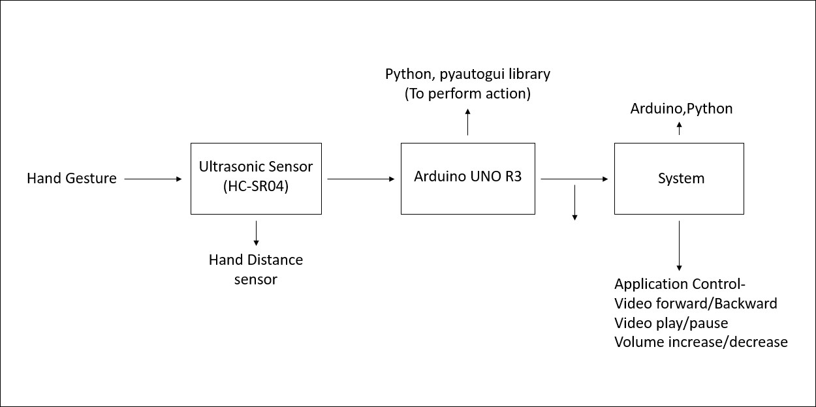

Fig 4: basic layout

Here we can see that two ultrasonic sensors(HC-SR04) are connected to Arduino Uno R3 board and the board is connected to Laptop through USB cable. The ultrasonic sensors have a transmitter and a receiver where the transmitter emits ultrasonic waves. The waves hit a surface in front of the sensor and any reflected waves are picked up by the transmitter and based on the intensity the distance of the object is determined. This data is received by the Arduino and looks for specific keywords within the code according to the distance that is to be sent to the Python code. Python takes the keyword and create a virtual keystroke of hot keys. The sensors with the help of ultrasonic waves measures the distance between the hand and the sensors and by the help of that the volume of the media player will be increased or decreased and same thing happens with the forward and backward of the video player

**CHAPTER-7**

**CIRCUIT DIAGRAM**

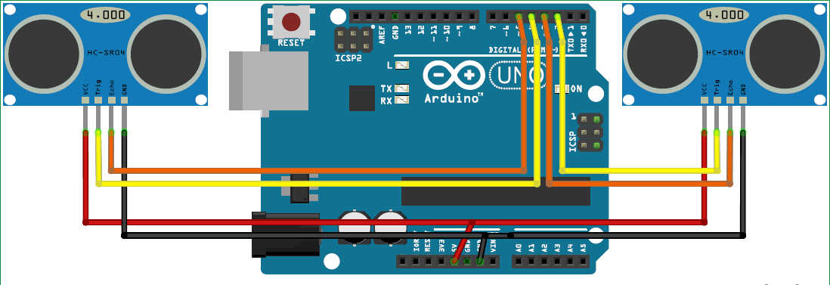

Fig 5: circuit diagram

As we can see in Fig 2.2 here, two ultrasonic sensors are connected to Arduino Uno board and the board is connected to Laptop through USB cable. The Vcc pin of each sensor is provided by Arduino using the 5V output port. Grounding of both sensors is attached to GND0 and GND1. The Trigger and Echo pins are connected as per the code written. The ultrasonic sensors are equipped with a transmitter and a receiver where the transmitter emits ultrasonic waves. The waves hit a surface in front of the sensor and any reflected waves are picked up by the transmitter and based on the intensity the distance of the object is determined.

This data is received by the Arduino and looks for specific keywords within the code according to the distance that is to be sent to the Python code running in the background of Windows. Python picks up the keywords and generates virtual keystrokes of hot keys for the VLC media player. This process is kept on a continuous loop to control media playback, either video or audio files.

The ultrasonic sensors are the components that read the hand gesture and he distance of the hand from the sensor. For the left sensor, bringing our hand closer to it will rewind the video and moving away from it will fast forward the video. In the right sensor, the same actions would result in controlling the volume of the media player.

**CHAPTER-8**

**PYTHON CODE**

import serial #Serial imported for Serial communication import time #Required to use delay functions

import pyautogui #Required to to perform actions

ArduinoSerial = serial.Serial('com3',9600) #Create Serial port object called arduinoSerialData

time.sleep(2) #wait for 2 seconds for the communication to get established

while 1:

incoming = str (ArduinoSerial.readline()) #read the serial data and print it as line

print incoming

if 'Play/Pause' in incoming: pyautogui.typewrite(['space'], 0.4)

if 'Rewind' in incoming: pyautogui.hotkey('ctrl', 'left')

if 'Forward' in incoming: pyautogui.hotkey('ctrl', 'right')

if 'Volume Incresaed' in incoming: pyautogui.hotkey('ctrl', 'down')

if 'Volume Decreased' in incoming: pyautogui.hotkey('ctrl', 'up')

incoming = "";

**CHAPTER-9**

**ARDUINO CODE**

const int trigger1 = 2; //Trigger pin of 1st Sesnor const int echo1 = 3; //Echo pin of 1st Sesnor const int trigger2 = 4; //Trigger pin of 2nd Sesnor const int echo2 = 5;//Echo pin of 2nd Sesnor

long time_taken; int dist,distL,distR;

void setup() { Serial.begin(9600);

pinMode(trigger1, OUTPUT); pinMode(echo1, INPUT); pinMode(trigger2, OUTPUT); pinMode(echo2, INPUT);

}

/*###Function to calculate distance###*/ void calculate_distance(int trigger, int echo)

{

digitalWrite(trigger, LOW); delayMicroseconds(2); digitalWrite(trigger, HIGH); delayMicroseconds(10); digitalWrite(trigger, LOW);

time_taken = pulseIn(echo, HIGH); dist= time_taken*0.034/2;

if (dist>60)

dist = 60;

}

void loop() { //infinite loopy calculate_distance(trigger1,echo1); distL =dist; //get distance of left sensor

calculate_distance(trigger2,echo2); distR =dist; //get distance of right sensor

//Pause Modes -Hold

if ((distL >40 && distR>40) && (distL <60 && distR<60)) //Detect both hands

{Serial.println("Play/Pause"); delay (500);}

calculate_distance(trigger1,echo1); distL =dist;

calculate_distance(trigger2,echo2); distR =dist;

//Control Modes

//Lock Left - Control Mode

if (distL>=13 && distL<=17)

{

delay(100); //Hand Hold Time calculate_distance(trigger1,echo1); distL =dist;

if (distL>=13 && distL<=17)

{

Serial.println("Left Locked"); while(distL<=40)

{

calculate_distance(trigger1,echo1); distL =dist;

if (distL<10) //Hand pushed in

{Serial.println ("Volume Increased"); delay (300);} if (distL>20) //Hand pulled out

{Serial.println ("Volume Decreased"); delay (300);}

}

}

}

//Lock Right - Control Mode if (distR>=13 && distR<=17)

{

delay(100); //Hand Hold Time calculate_distance(trigger2,echo2); distR =dist;

if (distR>=13 && distR<=17)

{

Serial.println("Right Locked"); while(distR<=40)

{

calculate_distance(trigger2,echo2); distR =dist;

if (distR<10) //Right hand pushed in

{Serial.println ("Rewind"); delay (300);} if (distR>20) //Right hand pulled out

{Serial.println ("Forward"); delay (300);}

}

}

}

delay(200);

**CHAPTER-10**

# IMPLENTATION

### C:\Users\aksha\Desktop\mini project\implimentation pics\python install.PNGInstall python –

**Install Arduino IDE –**

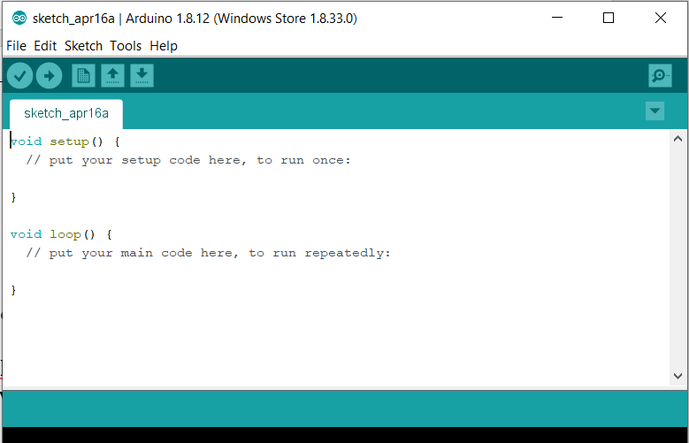

Fig 6: installation of python and Arduino

### Install PySerial and PyAutoGui libraries and check whether it is working or not –

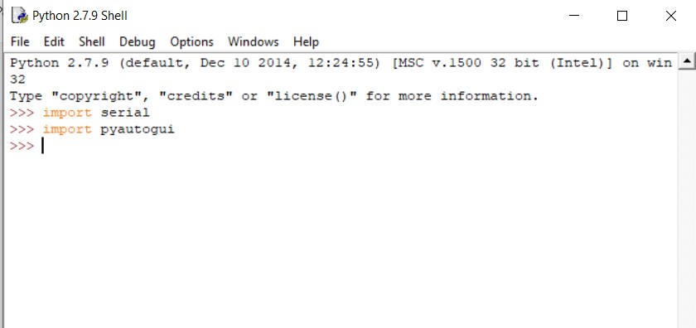

**Now connect the Arduino with ultrasonic sensors and with jumper wire and fix both in the back of your laptop and connect it with USB cable.**

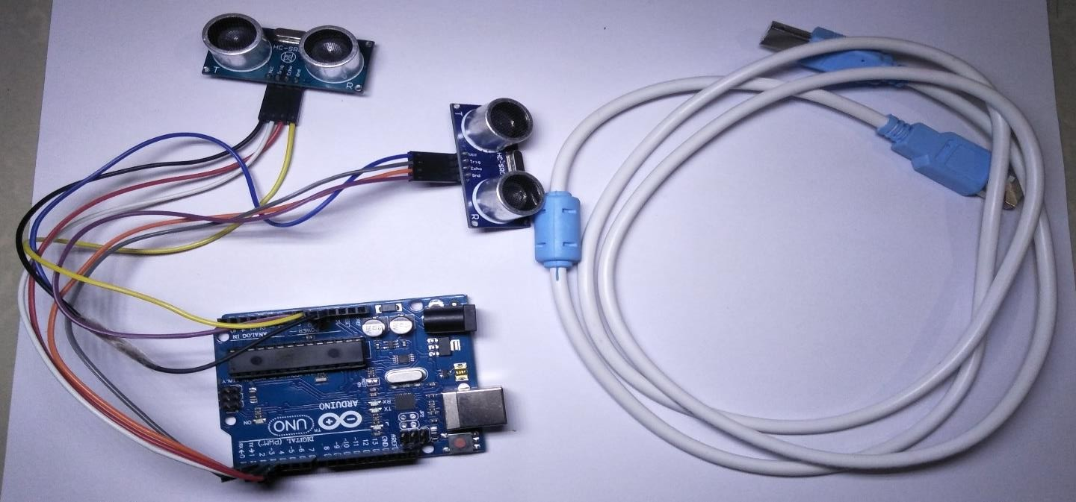

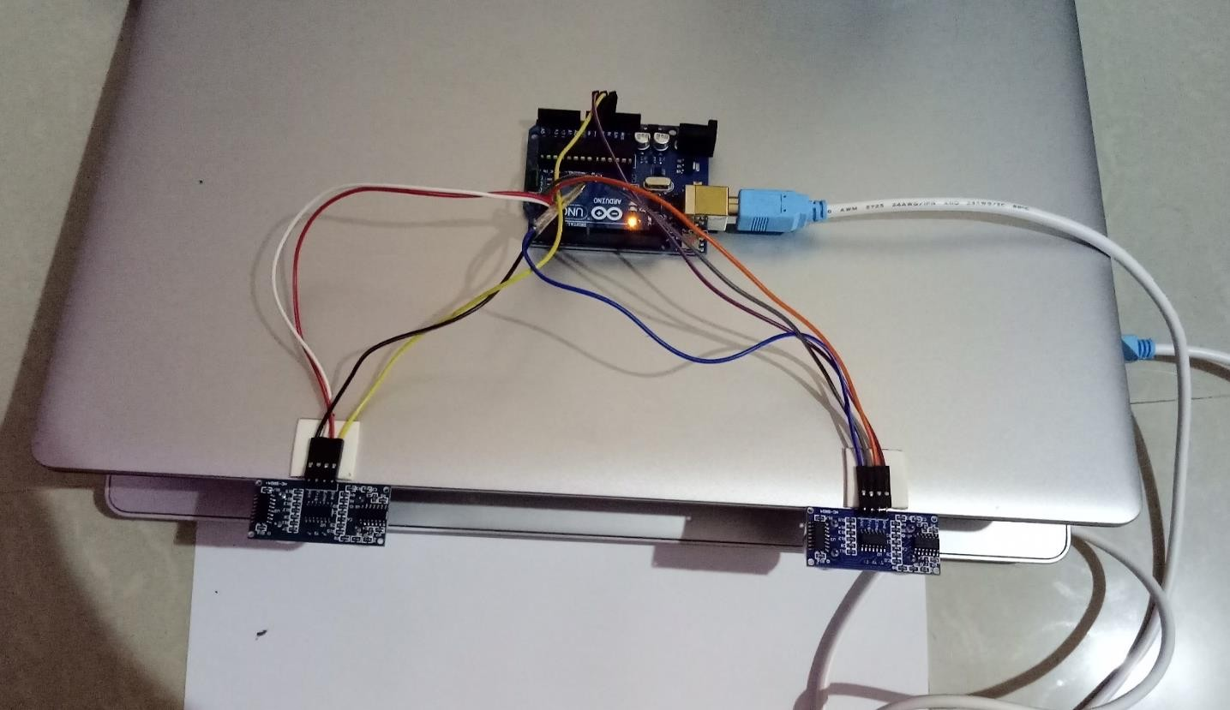

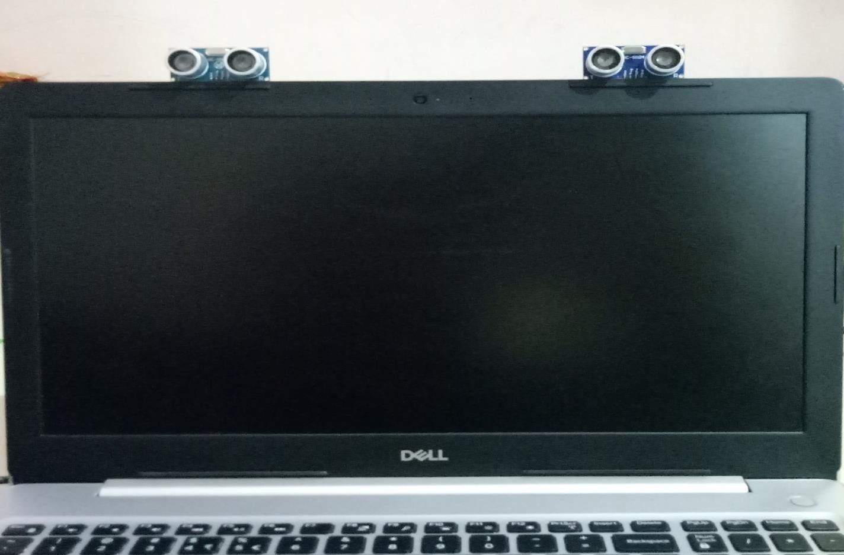

**Copy the Arduino code into Arduino IDE –**

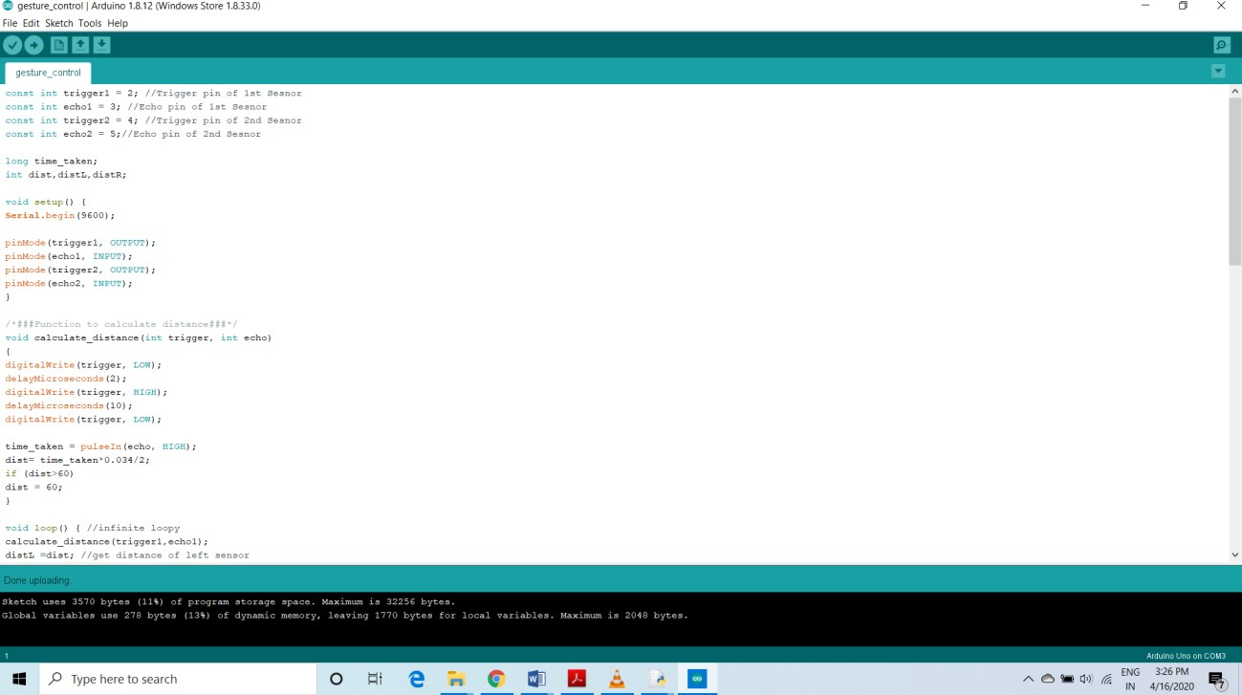

**Copy the python code in python IDE and run it.**

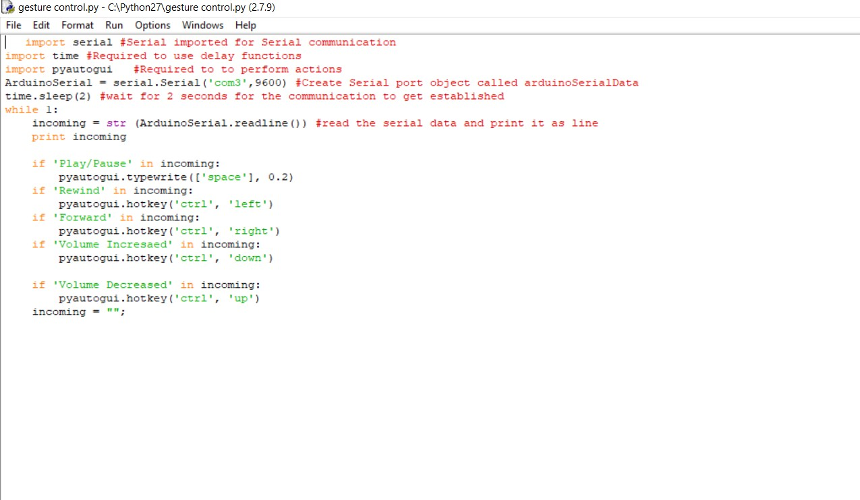

Fig 7: python and Arduino code

### Program executed successfully and connection to the Arduino has been also set –

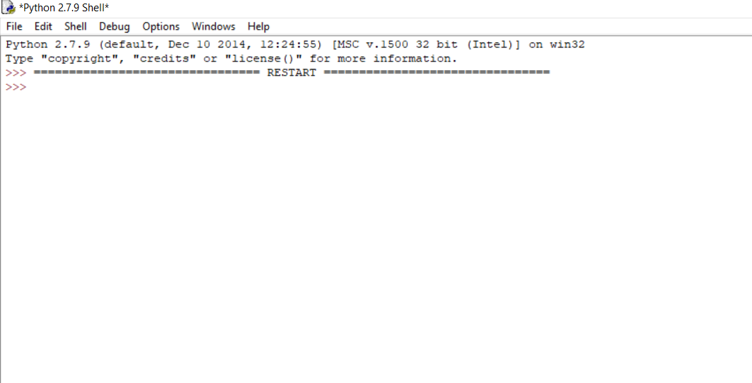

**Now open VLC media player and control the video with your hand motion –**

* + **Play**
  + **Pause**
  + **Forward**
  + **Backward**
  + **Volume up**
  + **Volume down**

**Volume up -**

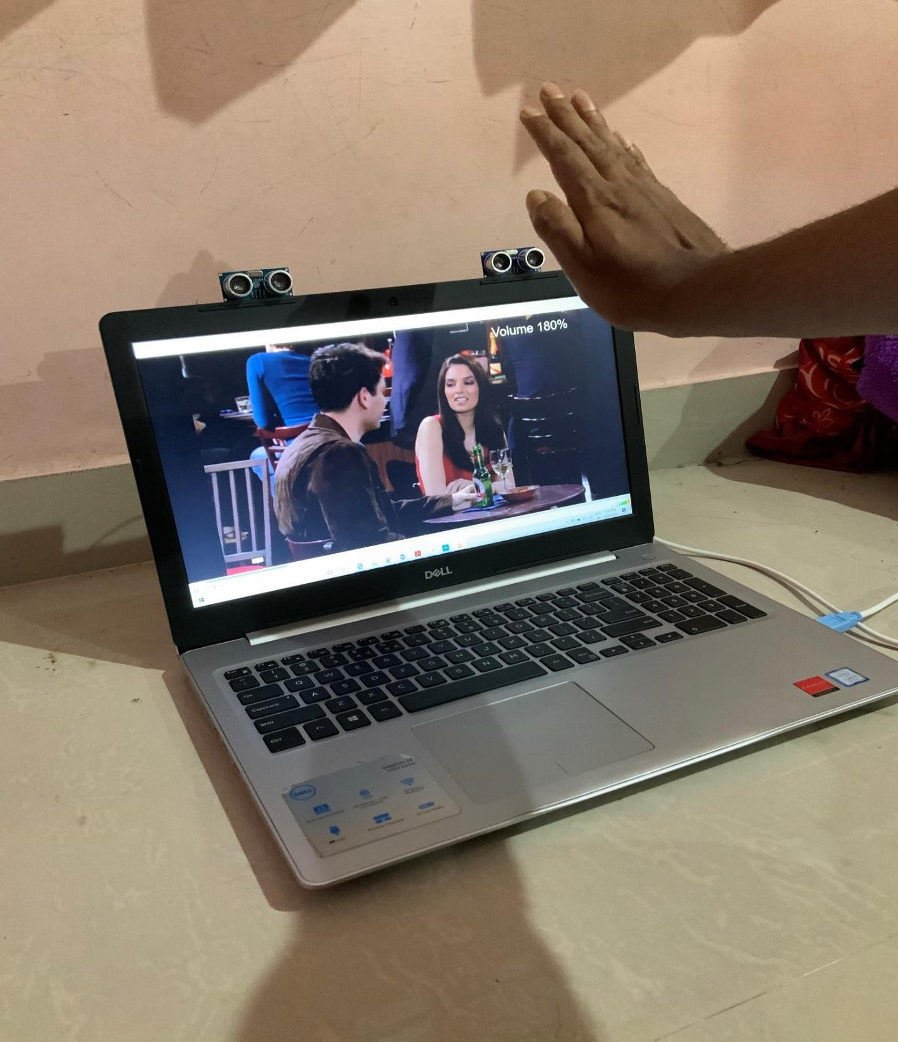

Fig 8: volume up

### Volume down -

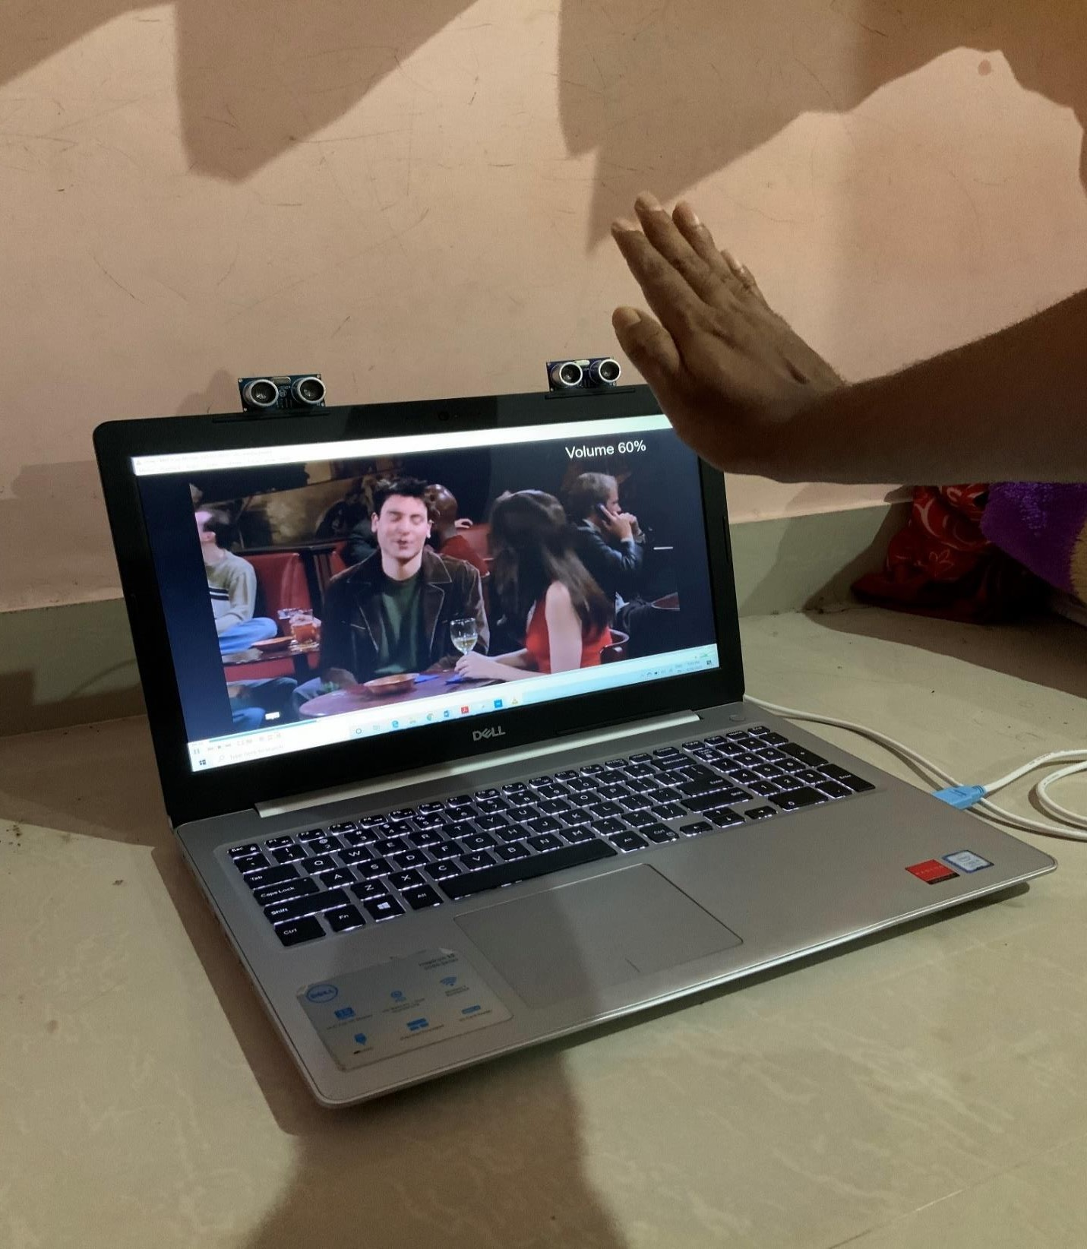

Fig 9: volume down

### Forward -

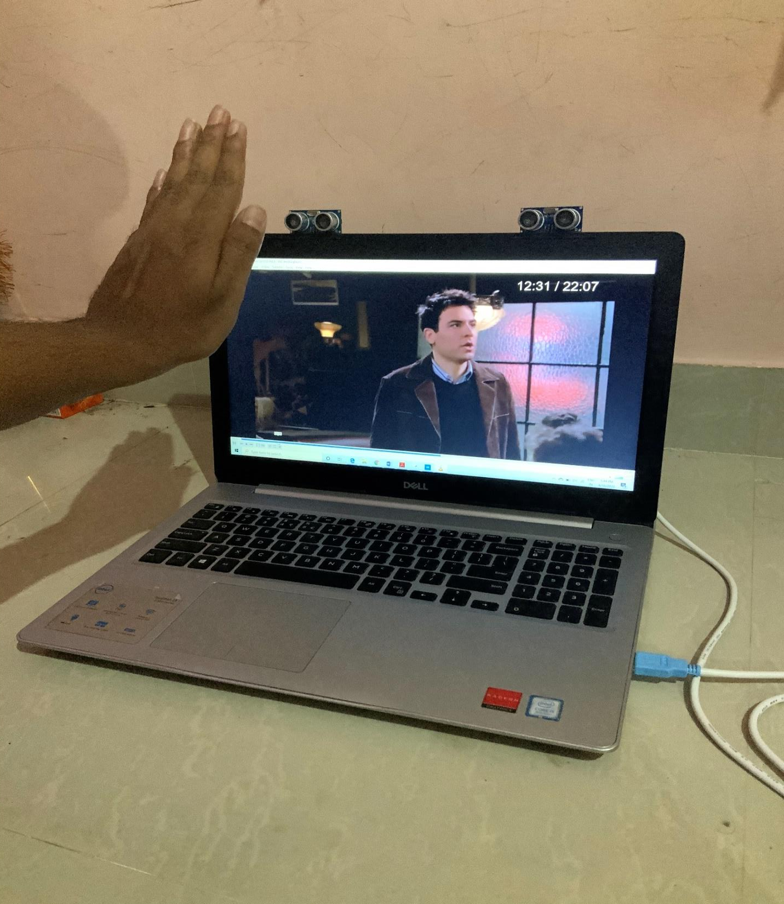

Fig 10: forward

### Backward -

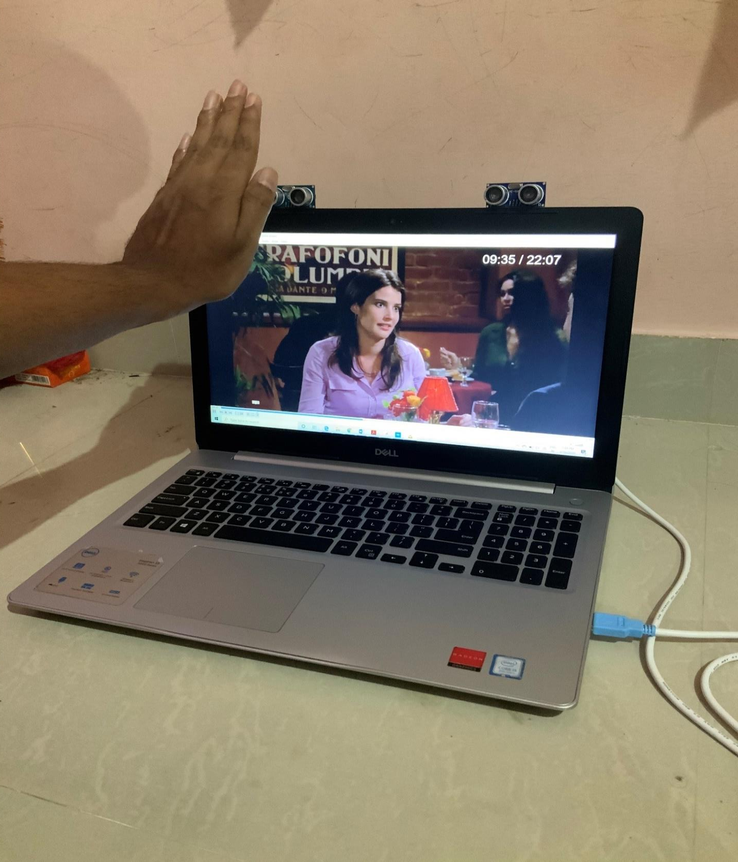

Fig 11: backward

### Play –

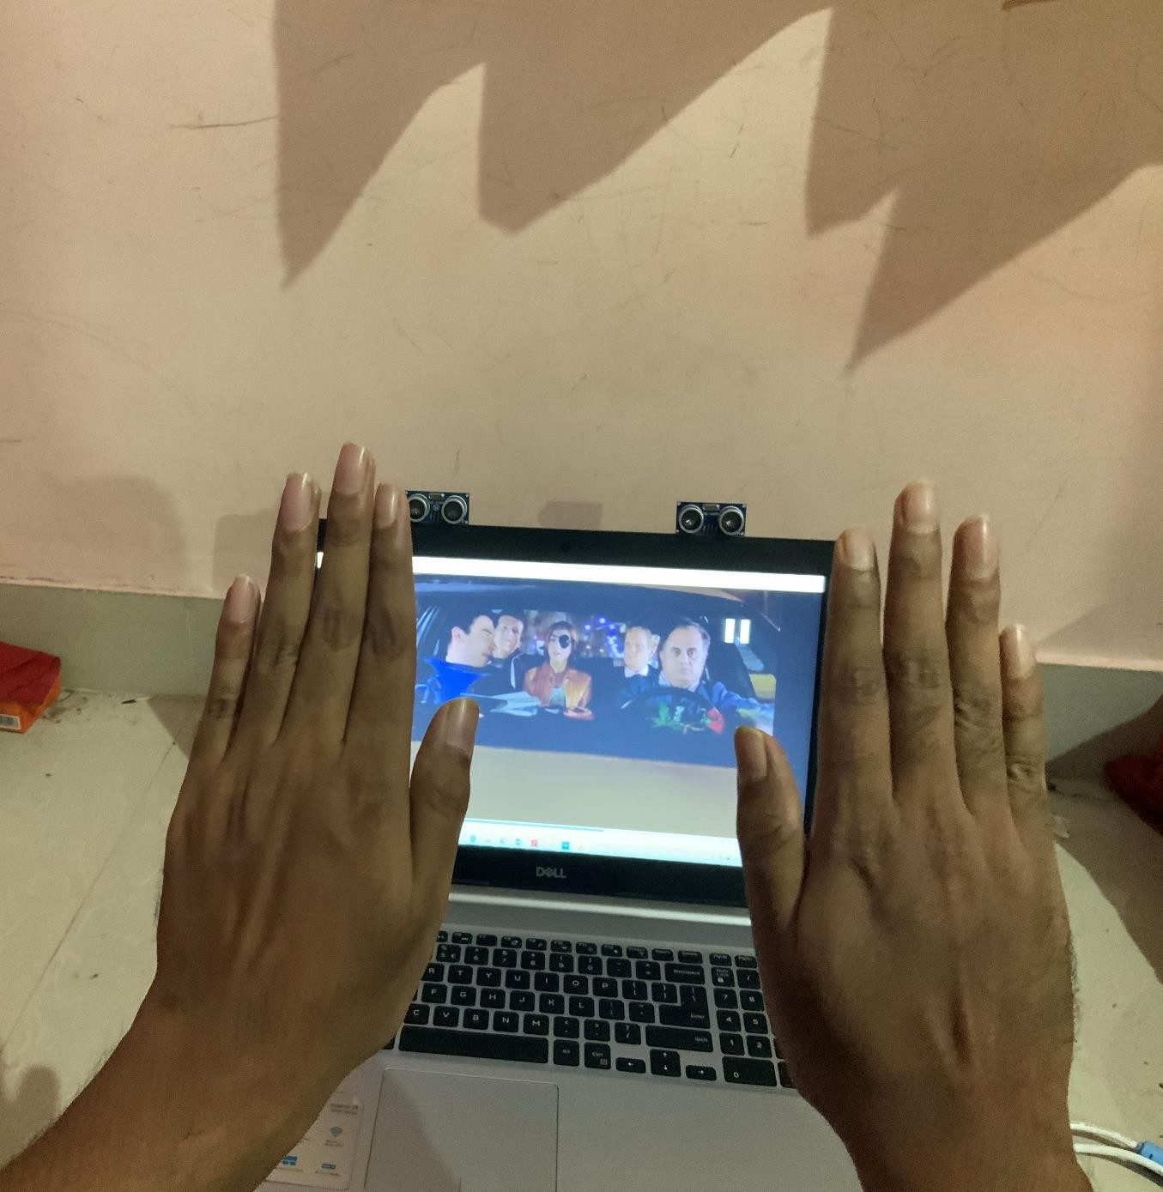

Fig 12: play

### Pause –

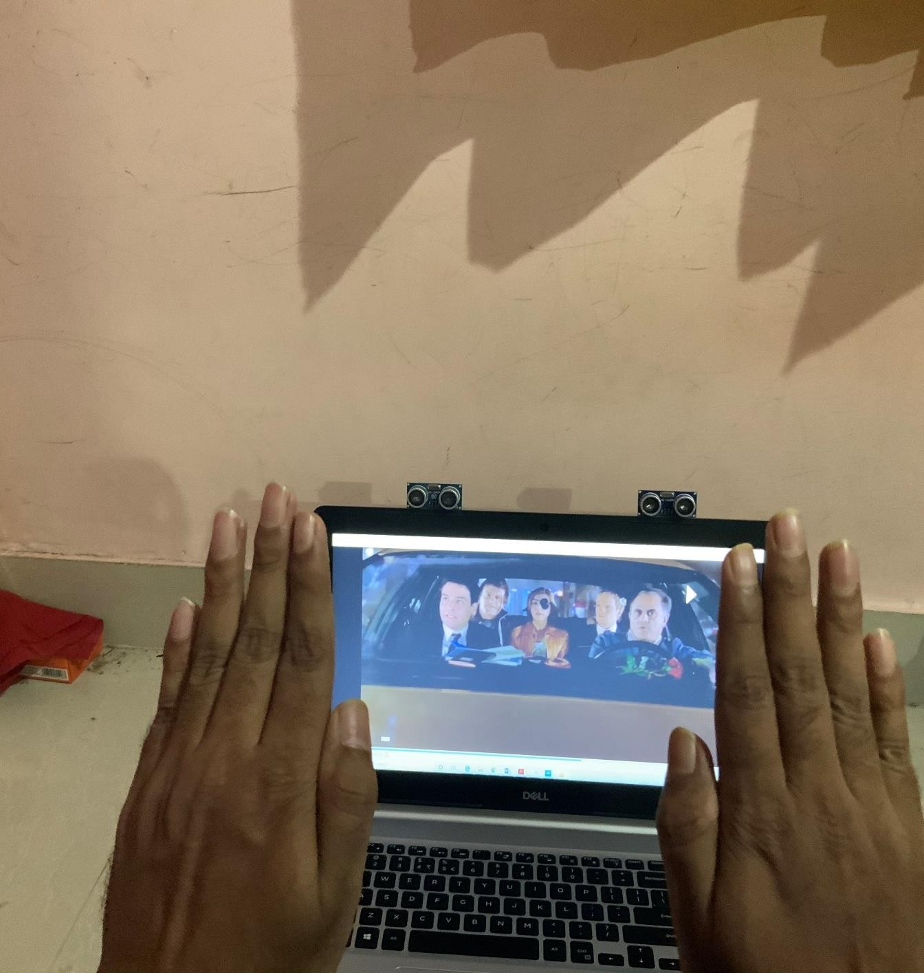

Fig 13: pause

**CHAPTER-11**

# OUTPUT

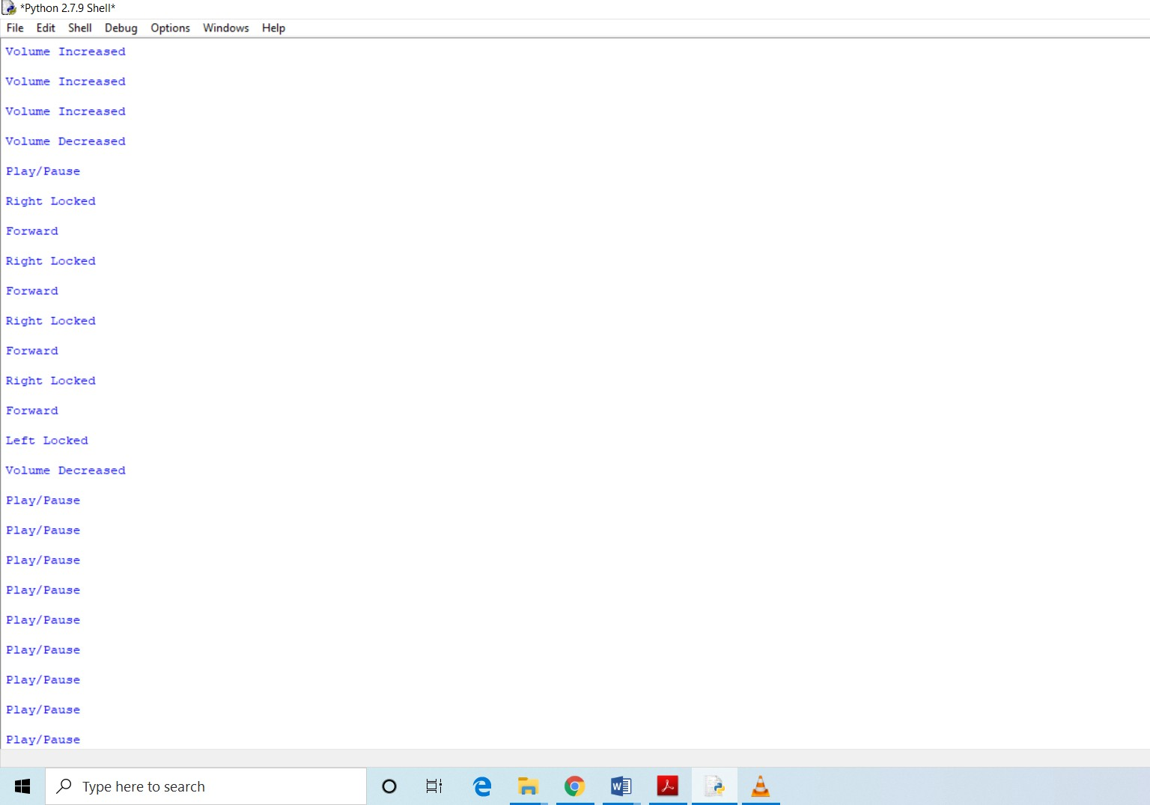

Fig14: output

**CHAPTER-12**

# FUTURE DEVELOPMENT

1. This project can be further implemented on platform like AVR, ARM microcontroller etc.
2. We can add many video controlling features just by modifying the python code.
3. We can integrate this type of module for many applications like browsers, designing and editing applications, gaming etc.
4. The knowledge is ever expanding and so are the problems which the mankind strives to solve.

# CONCLUSION

The gesture control system uses two ultrasonic sensors, Arduino UNO, and a system to carry the operation of video player controller. Its main motive is to reduce the effort of interacting with the system with the input devices and using simple hand gestures instead of that. It increases interactivity with computers. This type of technology can be used in giving presentations, classrooms for easier .

# REFERENCES AND BIBILOGRAPHY

1. Author: Rohit Mukherjee1, Pradeep Swethen2, Ruman Pasha3, Sachin Singh Rawat4

HAND GESTURE CONTROLLED LAPTOP USING ARDUINO

1. Author: G. Anil Kumar1, B. Sathwik2 GESTURE CONTROLLED VIDEO PLAYBACK
2. Author: Mayuri S. Khasale

COMPUTER CONTROL WITH HAND GESTURES USING ULTRASONIC SENSOR

1. Author: Surya Mishra1, T. Dhikhi2 GESTURE CONTROL KEYBOARD

# BIBLIOGRAPHY

1. [https://www.instructables.com/id/Amazing-Control-Computer- Using-Hand-Motion-and-Ard/](https://www.instructables.com/id/Amazing-Control-Computer-Using-Hand-Motion-and-Ard/)
2. [https://technicalustad.com/control-your-pc-with-hand-gesture- using-arduino/](https://technicalustad.com/control-your-pc-with-hand-gesture-using-arduino/)
3. [https://appuals.com/how-to-make-arduino-based-hand-gesture- control-of-your-computer/](https://appuals.com/how-to-make-arduino-based-hand-gesture-control-of-your-computer/)
4. [https://www.electronicshub.org/arduino-based-hand-gesture- control-computer/](https://www.electronicshub.org/arduino-based-hand-gesture-control-computer/)
5. [https://create.arduino.cc/projecthub/smart-tech/amazing-control- computer-using-hand-motion-and-arduino-d933f1](https://create.arduino.cc/projecthub/smart-tech/amazing-control-computer-using-hand-motion-and-arduino-d933f1)
6. <https://www.youtube.com/watch?v=05jDQV4_uXU>